**Salesforce integration using sfdx method with Jenkins tool**

Salesforce is a leading customer relationship management (CRM) platform and cloud computing company. It offers a suite of software solutions and services designed to help organizations and streamline various aspects of their business, primarily focused on customer relationships, sales, marketing, and customer support.

Now we are deploying salesforce application using SFDX method with Jenkins tool.

**Architecture diagram**

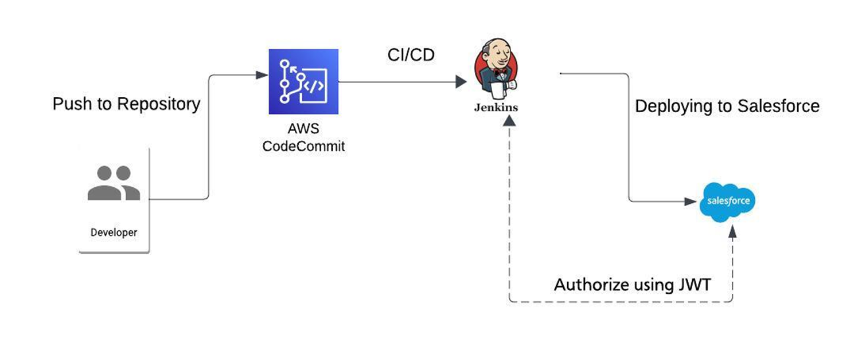

**Prerequisites:**

1. Jenkins

2. Salesforce account

3. Code commit

**Steps needs to be followed:**

1. Jenkins:

* + - Provision EC2 instance (either Linux/Ubuntu) and install Jenkins setup on the instance.

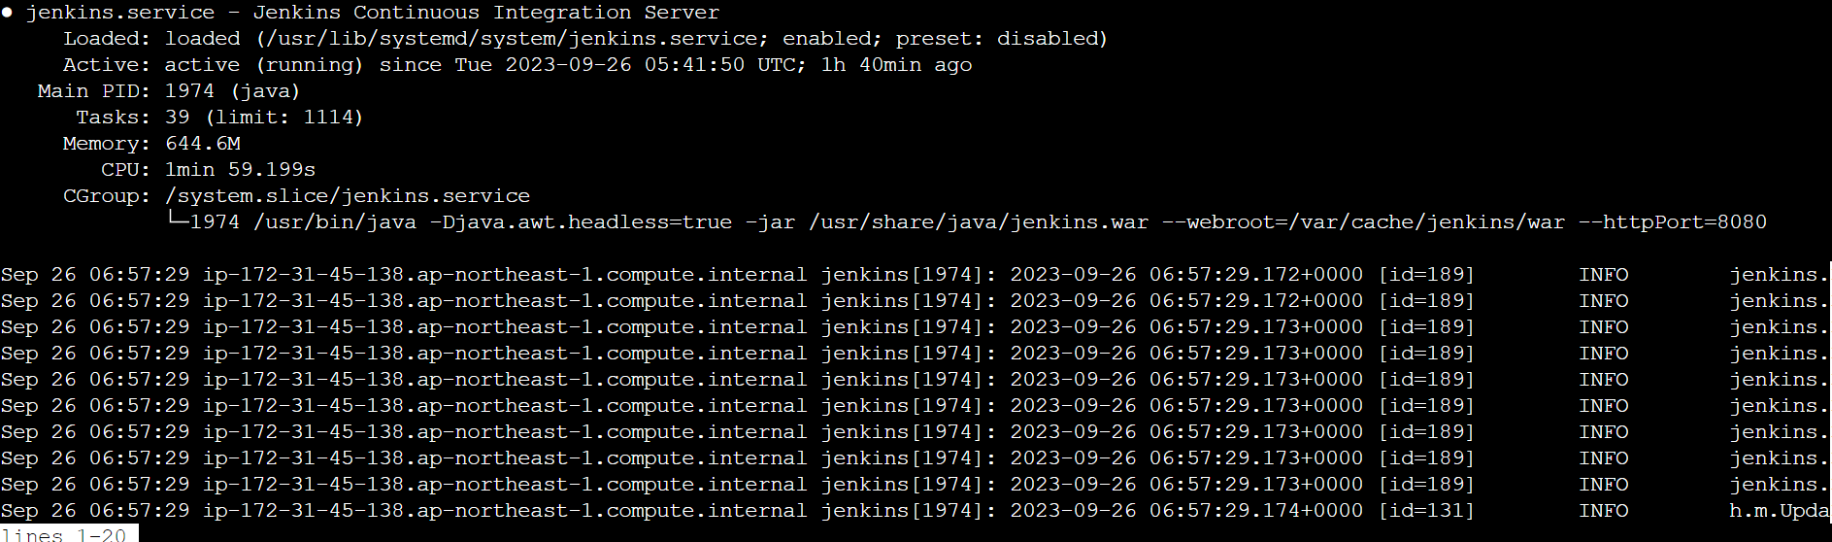

* + - Install Nodejs and NPM in server by following the below link.

<https://nodejs.org/en/download>

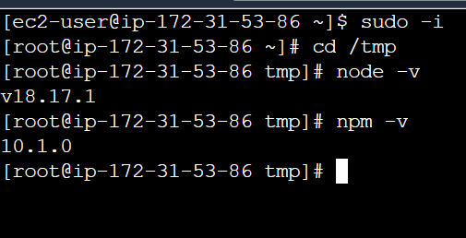

* + - Install salesforce-cli in the server

<https://developer.salesforce.com/docs/atlas.en-us.sfdx_setup.meta/sfdx_setup/sfdx_setup_install_cli.htm#sfdx_setup_install_cli_linux>

For installation of salesforce-cli sfdx : yum install salesforce-cli -y

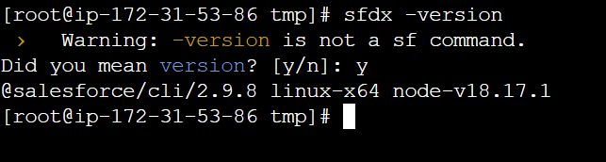

* + - Install sfdx, sf in the Jenkins server.

**Setup JWT Flow to Integrate Jenkins with Salesforce**

* + - Create openssl,
* Yum install openssl -y
* If we want, we can create in a directory.
* By following command vi ~/.bashrc add below line:

**export openssl_conf=/etc/ssl/openssl.cnf**

* Source ~/.bashrc

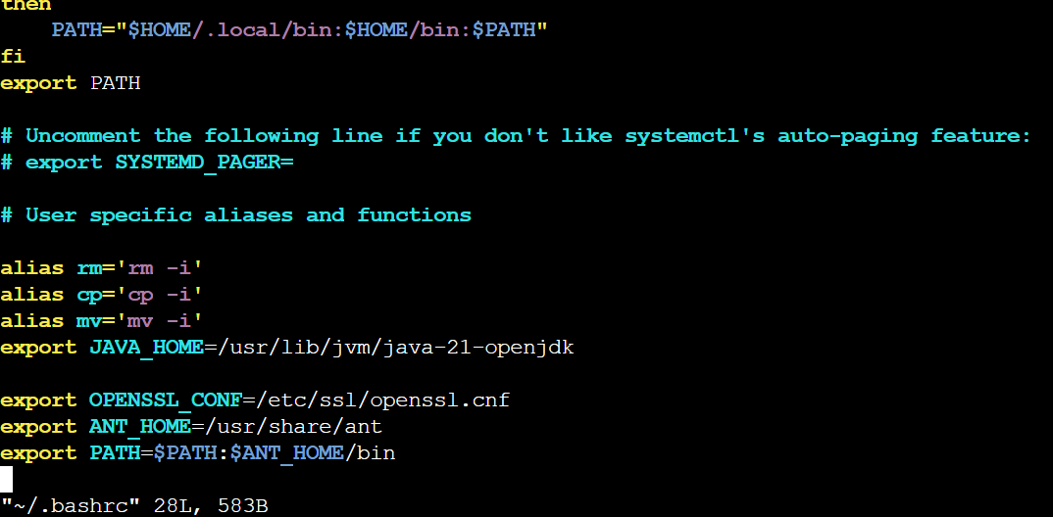

* **Generate an RSA private key:**  
  openssl genrsa -des3 -passout pass:x -out server.pass.key 2048
* **Create a key file from the server.pass.key file**:   
  openssl rsa -passin pass:x -in server.pass.key -out server.key
* **Request and generate the certificate**:  
  openssl req -new -key server.key -out server.csr
* **Generate the SSL certificate**:   
  openssl x509 -req -sha256 -days 365 -in server.csr -signkey server.key -out server.crt

<https://developer.salesforce.com/docs/atlas.en-us.sfdx_setup.meta/sfdx_setup/sfdx_setup_install_cli.htm#sfdx_setup_install_cli_linux>

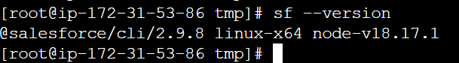

### Create Connected App for JWT-Based Flow:

Now it time to setup the connected app in Salesforce for Jenkins Deployment.

1. Created Connected App
   1. Callback URL  
      **http://<jenkins-serveripaddress>:1717/OauthRedirect**
   2. Use digital signatures to upload your **server.crt** file.
2. Edit policy and select “**Admin approved users are pre-authorized “**.
3. Assign Connected App to user or System Admin profile.

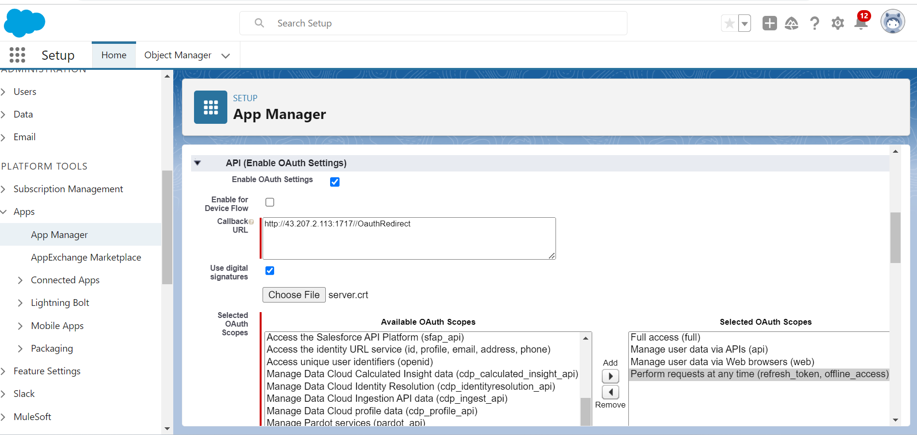

**Validate Authorize an Org Using the JWT-Based Flow:**

After creation of the connected App, click on manage and edit the policy “Admin approved users are pre-authorized”

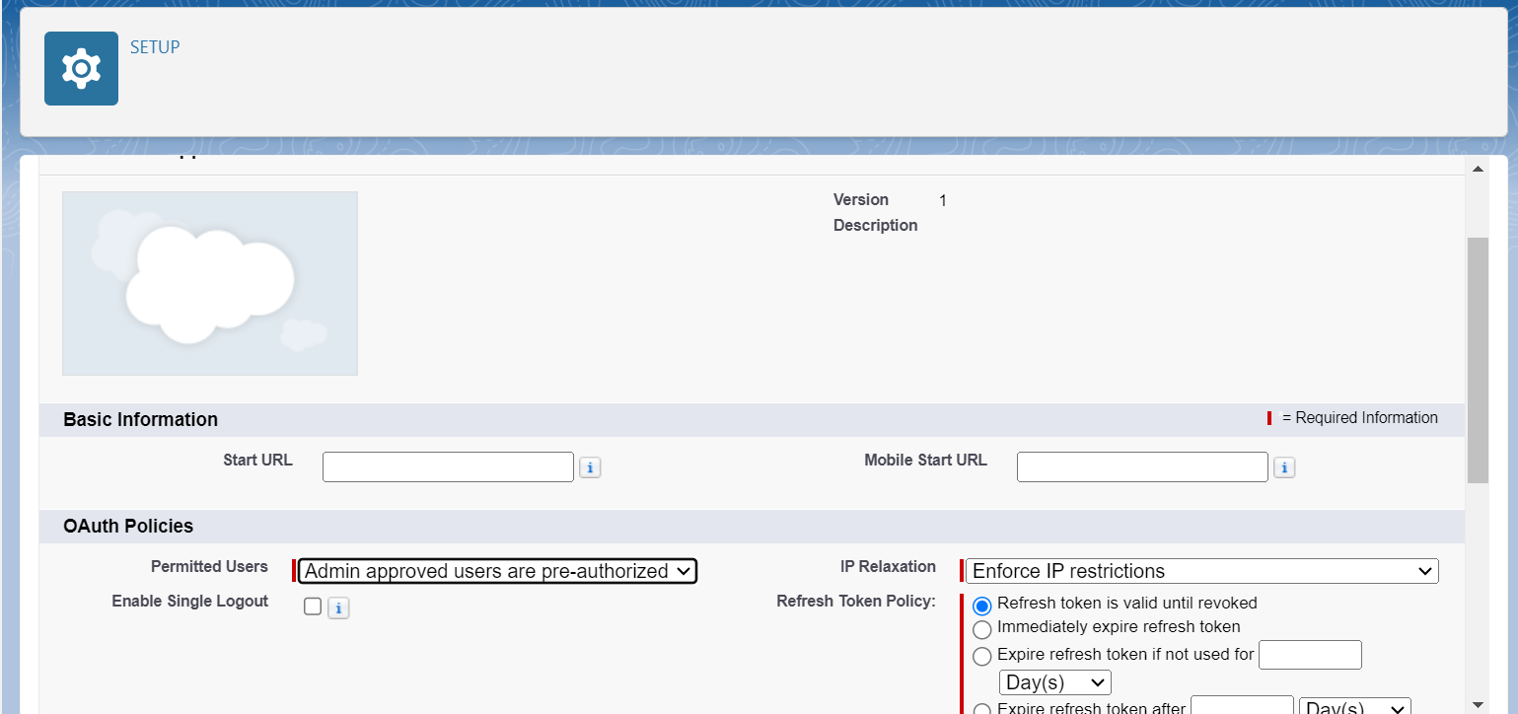

Go to connected Apps, Manage Profiles, select system administrator access.

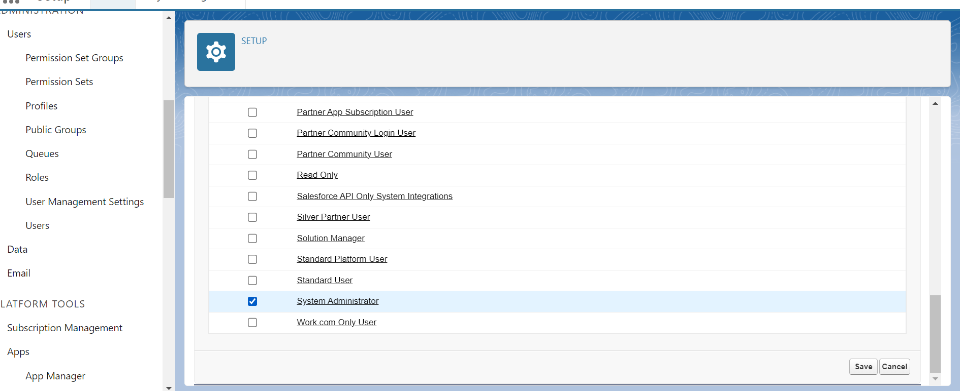

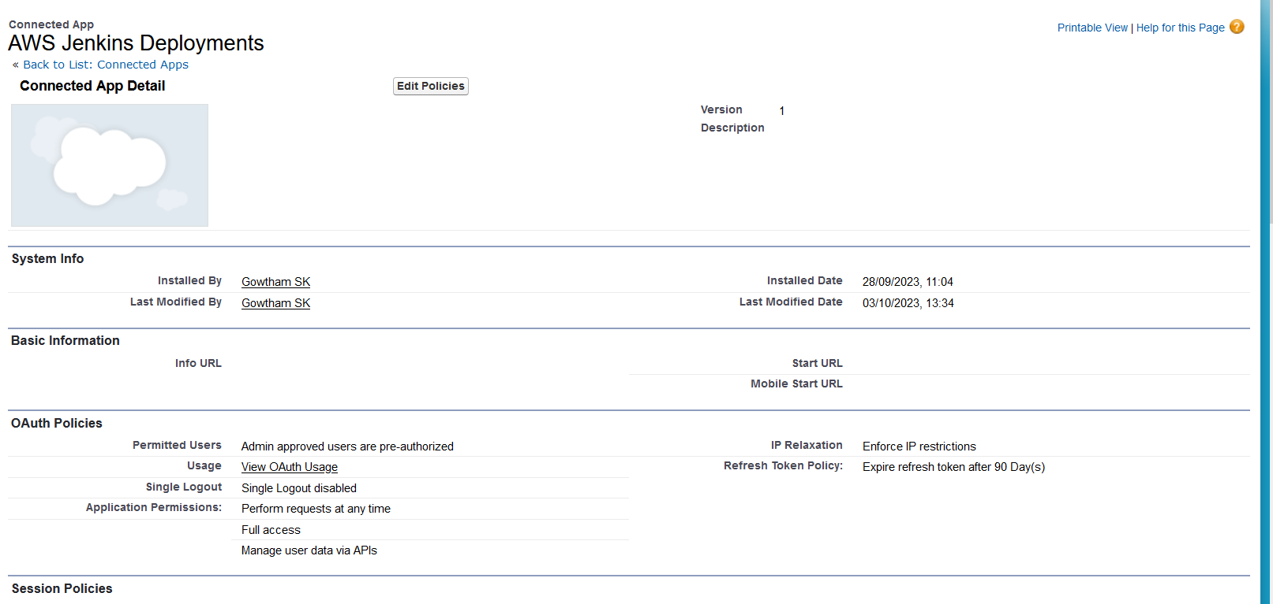

Click on Manage consumer details and get consumer key and secret key.

Validate Authorize an Org Using the JWT-Based Flow

**Execute below command to validate the authorization for an org using JWT-based flow:**

sfdx force:auth:jwt:grant --clientid 3MVG9CP2Kv.52YFtGUPcXiQI_3pzViupDxu24ye.0iDfFu6F38wXekZh5_o6COq3kDe3mx9GMZlBZuEvCE8bo --jwtkeyfile server.key --username devopstest@cholams.com --instanceurl <https://minfytech3-dev-ed.develop.my.salesforce.com> --setdefaultdevhubusername

**–clientid :-** provide Consumer Key

**–jwtkeyfile** :- Absolute path to the location where you generated your OpenSSL server.key file

–**instanceurl :-**provide instanceurl if you are using sandbox.

–**setdefaultdevhubusername :-** Set Default dev hub User Name.

### Configure the Jenkins:

### Add New Item. Then provide the project name and select type of project as Pipeline and run pipeline script.

### The deployment is succeeded

### 

After deploying the application, we can see deployment status on salesforce UI.

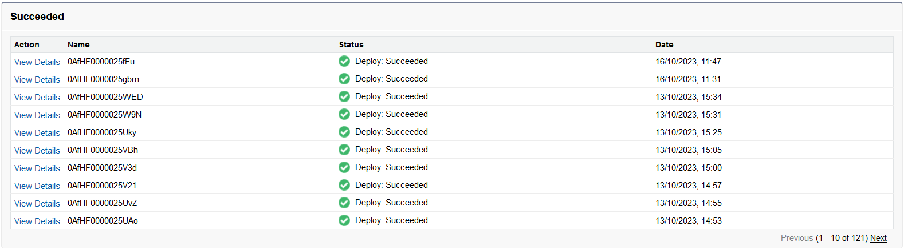

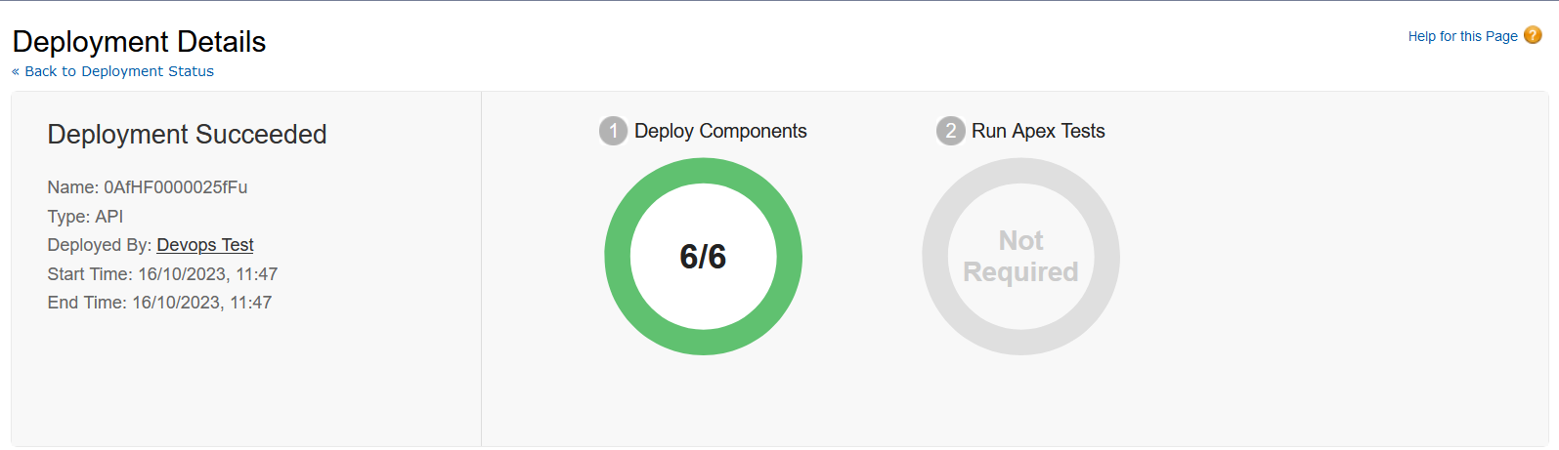

Under apex classes we can see the deployed files

